SANCHARSOFT – User guide ver 2.2

CSR LOGIN:

The CSR login is intended for the CSRs to cater for various activities such as sales, replacement, queries etc related to Prepaid cards, Recharge / Topup coupons and getting formatted reports according the categories.
The various menus used for Prepaid, Recharge / Topup cards are:
- Home
- Prepaid
- Recharge
- Replacement
- Stock
- Re-printing
- Reports
- Query
- Dealer sales

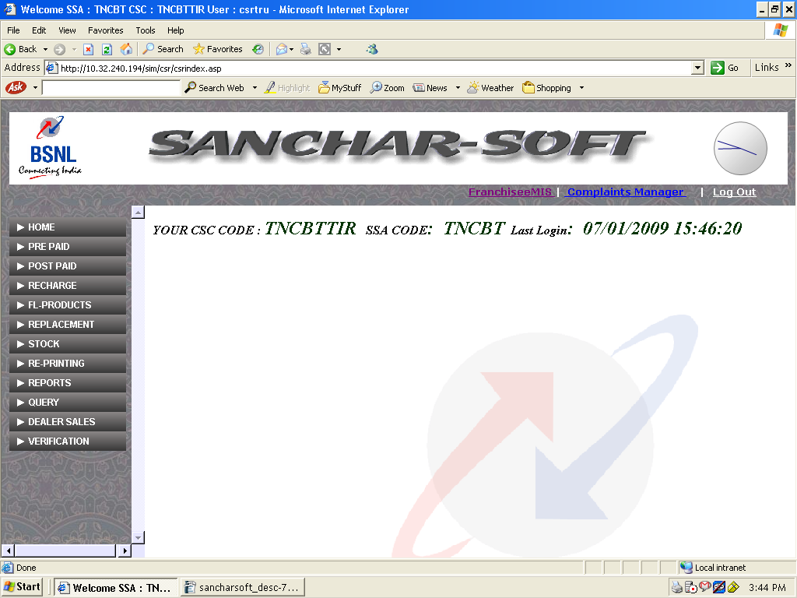
1. HOME:

Home menu displays the various available menus and also provides the facility to change the password of the current logged in user. The password should be minimum 3 characters and maximum 15 characters.

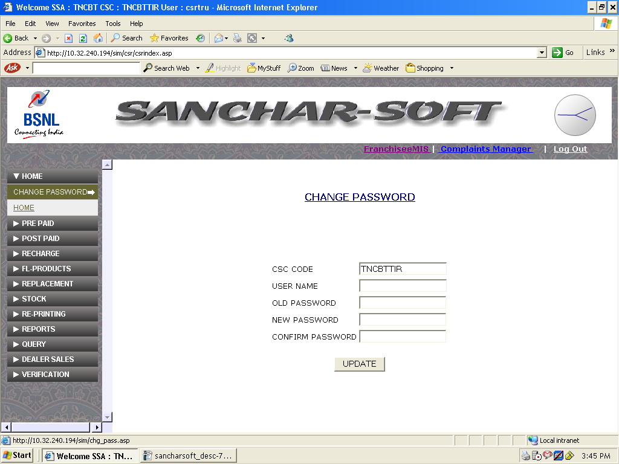

2. PREPAID:
Prepaid menu facilitates for sale of prepaid cards in two ways. One way is to select the required Mobile number from the available plans through the 'normal' sub menu . The other way is to select using the sub menu 'Prepaid by choice' wherin the selection may be done by entering the first 6 digits (minimum) of choice from the available stock. The sub menus are :
a) Normal
b) Prepaid by choice
c) Discount sale.
2.a) Normal: The Normal submenu provides the facility to sell a prepiad card from the available stock of the CSR. On selection of required Plan & GSM Number, the SIM number will be automatically displayed. Relevant coloums may filled in and on click of submit the SIM / MSISDN will be sent for activation, which is done in an given frequency for eg. once in 30 min.
The activation status of the SIM/MSISDN could be known from the 'ACTIVATION' menu.

Prepaid sales - Normal
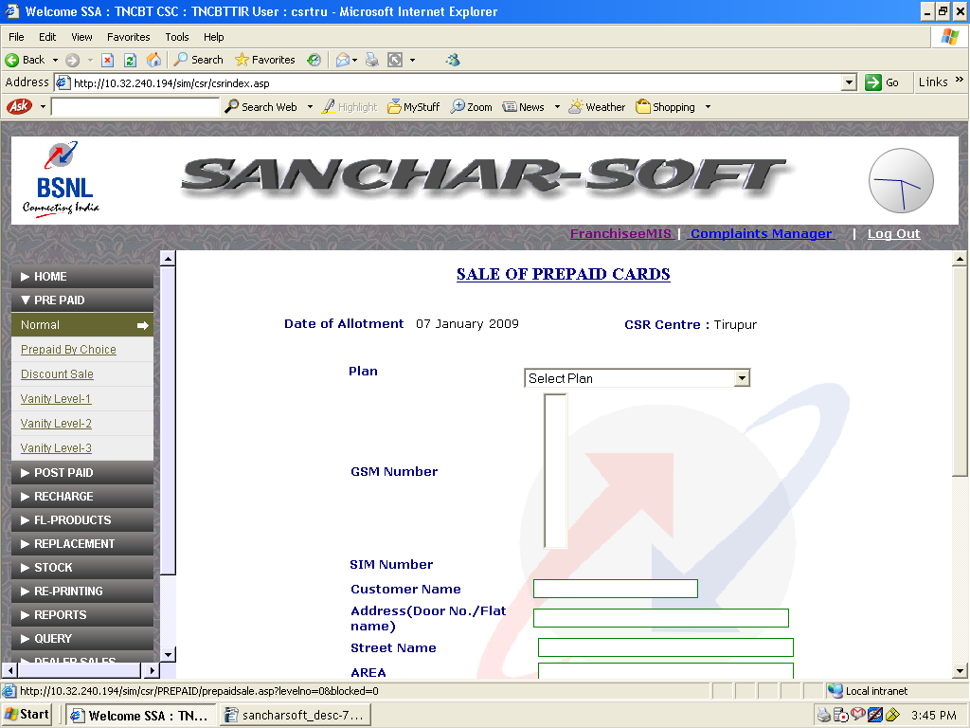
2.b) Prepaid by choice: This submenu provides the facility to sell a prepiad card from the available stock of the CSR by providing an option of searching for an particular pattern. On selection of required Plan, enter the pattern ( minimum 6 digits including the Level) for searching. The available MSISDN matching the selection pattern will be displayed. On selection of required GSM Number the SIM number will be automatically displayed. Relevant coloums may filled in and on click of submit the SIM / MSISDN will be sent for activation, which is done in an given frequency for eg. once in 30 min.
The activation status of the SIM/MSISDN could be known from the 'ACTIVATION' menu.

Prepaid sales by choice:
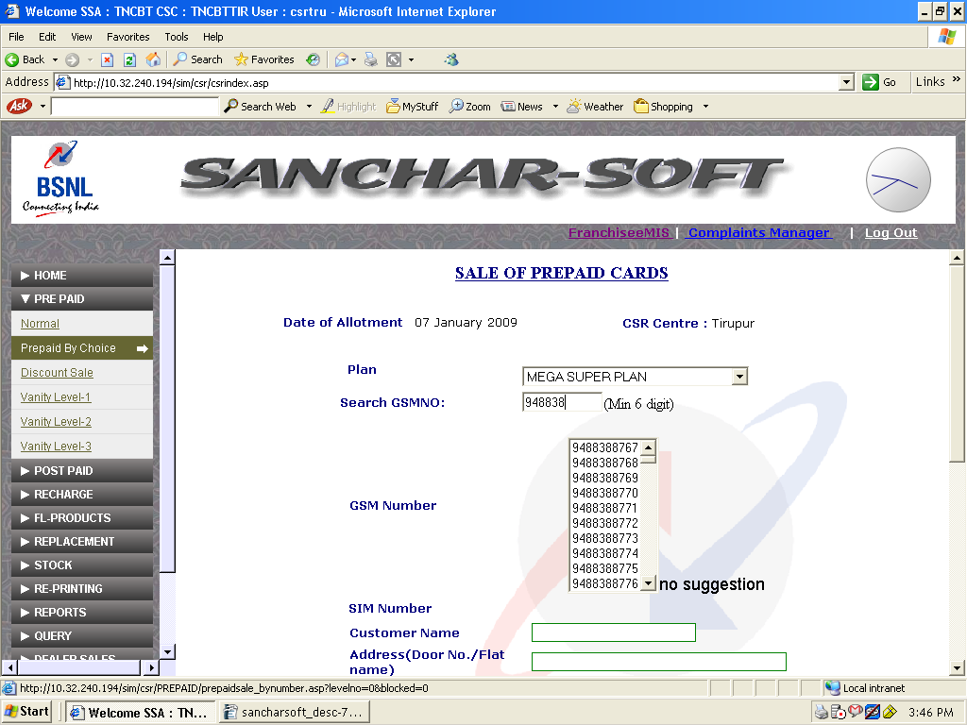

2.c) Discount Sale: Issue

This menu allows CSRs to issue recharge coupons or SIM cards meant for giving complimentary or free with other products as bundled items. This will be available on approval from AO of concerned SSA. Though the system gives complete list of inventory available, only approved quantity has to be issued . This has to be issued to persons specifically directed. For Example if Rs20/ top up cards to be given with every SIM card sold, you have to manually tally the freely issued TOP UP cards with SIM Sold. This menu may not be utilized unless specific authorization in writing about Quantity and authorized person/ customer to whom it should be given is got.

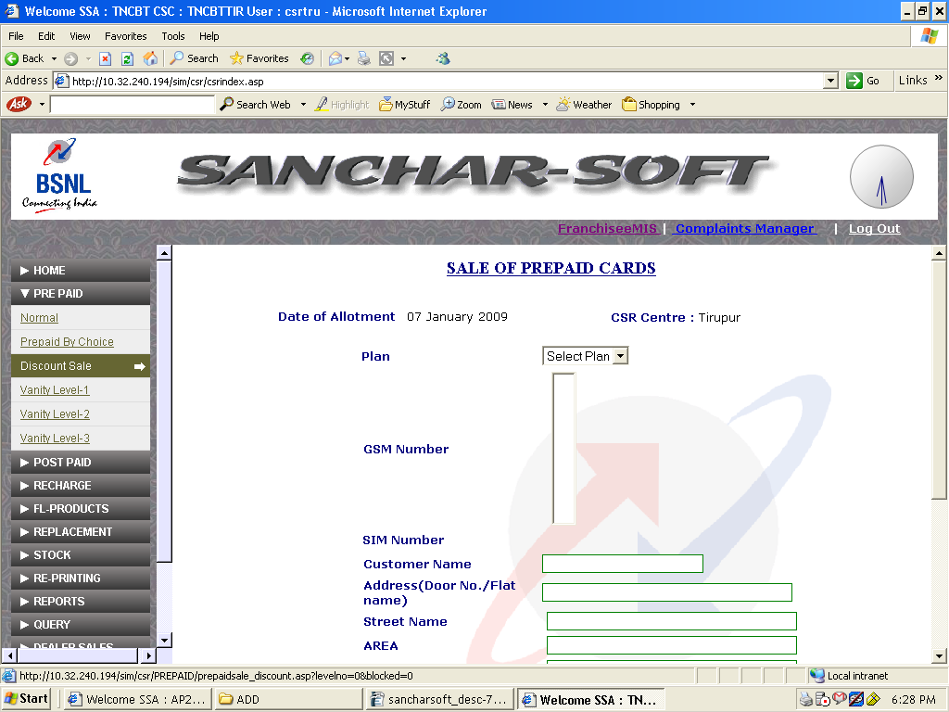
Discounted Sale:

3. RECHARGE:

Sale of Recharge / Top up cards, CTOPUP, CTOPUP Fexi & Deleting erroneous entries of one time updation done reg RCC/TopUp and Coupon blocking could be done through this Recharge menu. The sub menus are :

a) Coupons
b) CTOPUP Standard
c) CTOPUP Flexi
d) DELETE UPLOADED
e) Coupon Blocking
f) Offline sales.

3.a) Coupons:

Here through the ‘coupons’ sub menu, the process of selling Recharge / Top up cards could be done. Afetr selecting the Plan of coupon enter the mandatory fields
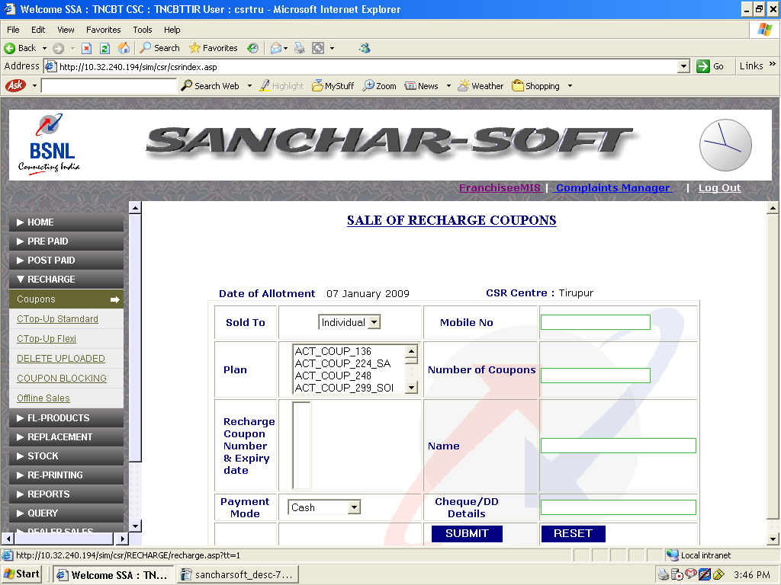

  - Delete Uploaded:

Any mistake committed during RC and top-up one time data entry , could be deleted using this sub menu. This facility will work only if no sale is done in that particular batch. Incase even if single voucher sold it can not deleted.

3.e) Coupon Blocking :

This facility is to be used after ensuring that legitimate ownership of RCC / TopUp. In case of lost RCC / TopUp coupons enough care may be exercised. It will be implemented only if concerned CMTS IN approves replacement.

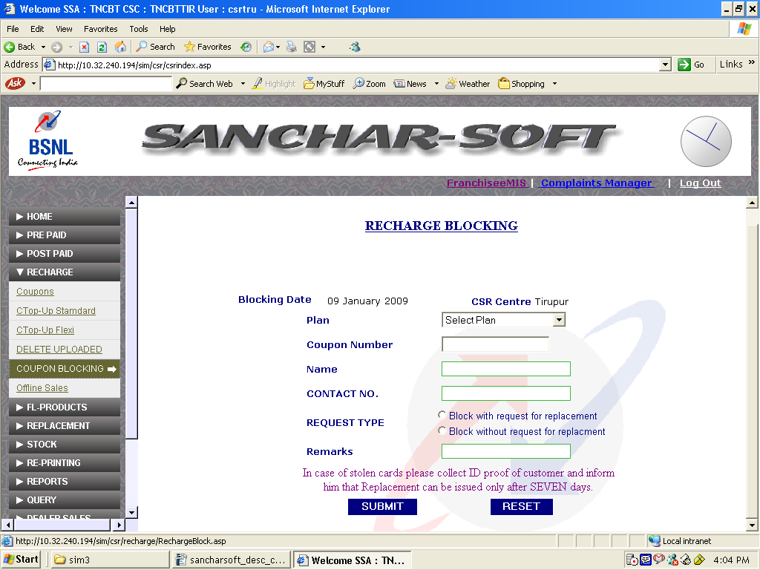

4. REPLACEMENT:

Replacement menu facilities the sale and accounting of SIM, Recharge / Topup cards that are replaced for reasons such as damaged /un-usable. In case of prepaid SIM Cards if caters for Normal, CTOP-UP and TIMSI cards.

Replacement – SIM cards

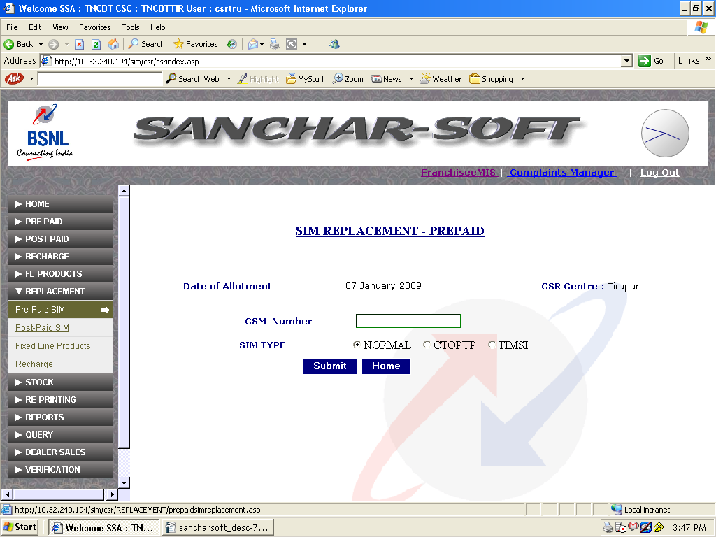

Replacement – Recharge / Top-Up coupons
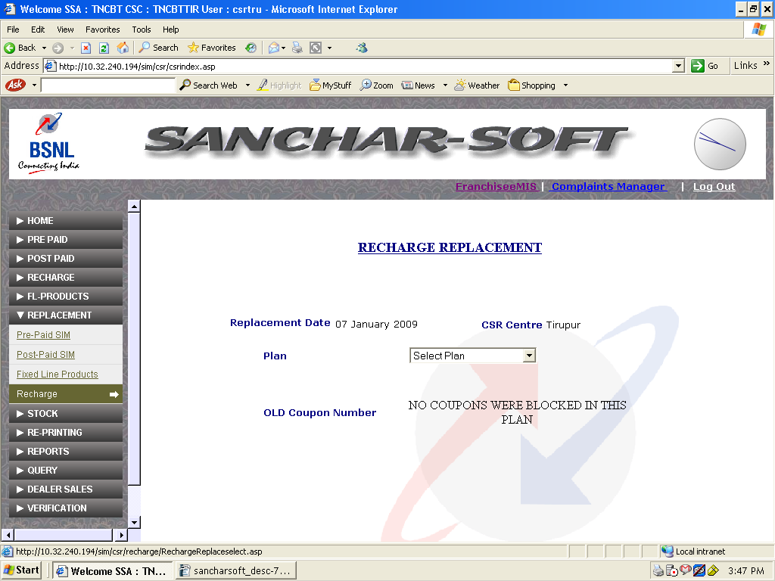

5) STOCK:

Stock menu provides the privilage of returning the expired / damaged stock, diversion of live stock from one unit to others and request /indent fresh stock for the concerned CSR.The sub menus are:
a) Stock return
b) Stock Diversion
c) Stock indent

5.a) Stock - Return

Stock Return sub menu provides the facility for returning back the expired or damaged/unusable stock back to the SSA A.O. After selecting the category, Plan the starting number may be selected. The Count to be return may be entered along with the reason and Add to surrender may be clicked folowed by clickin the CONFIRM SURRENDER .

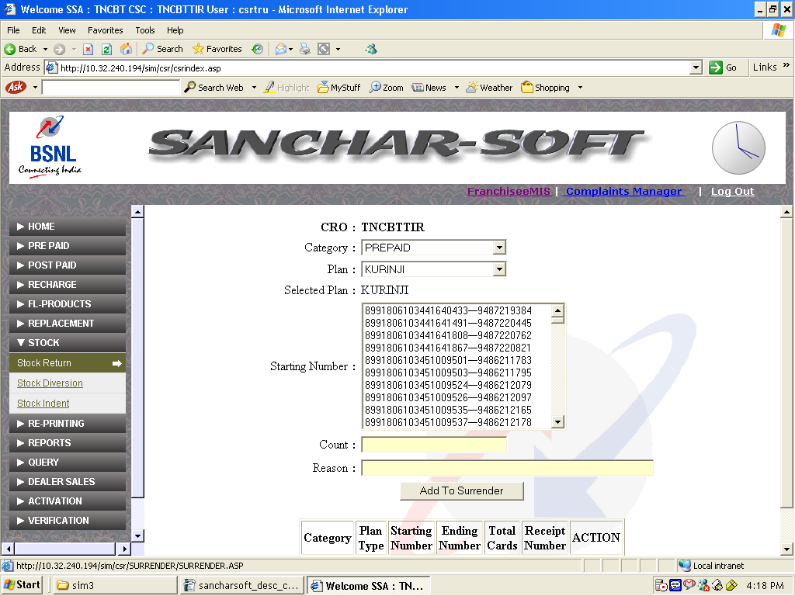

5.b) Stock – diversion

In case of stock diversion, it provides the facility for diverting live stock from one CSR to other CSR or back to Accounts Officer of the concerned SSA. Select the unit to divert, Product, Plan and the starting number. Total cards to be diverted may be entered and by clicking the CONFIRM button selected stock will be diverted to the intended unit.

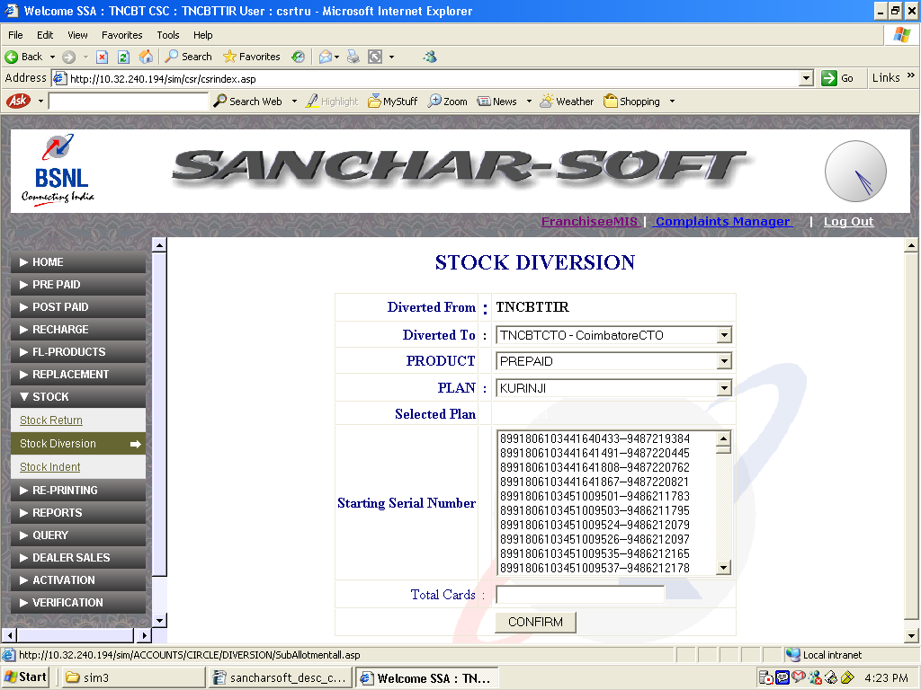

  - Stock – indent
Through Stock indent sub menu the CSR could indent for more stock. Select the product, Plan and enter the quantity required and click ADD. On confirmation the indent will be sent to the A.O for allotment of further stock.

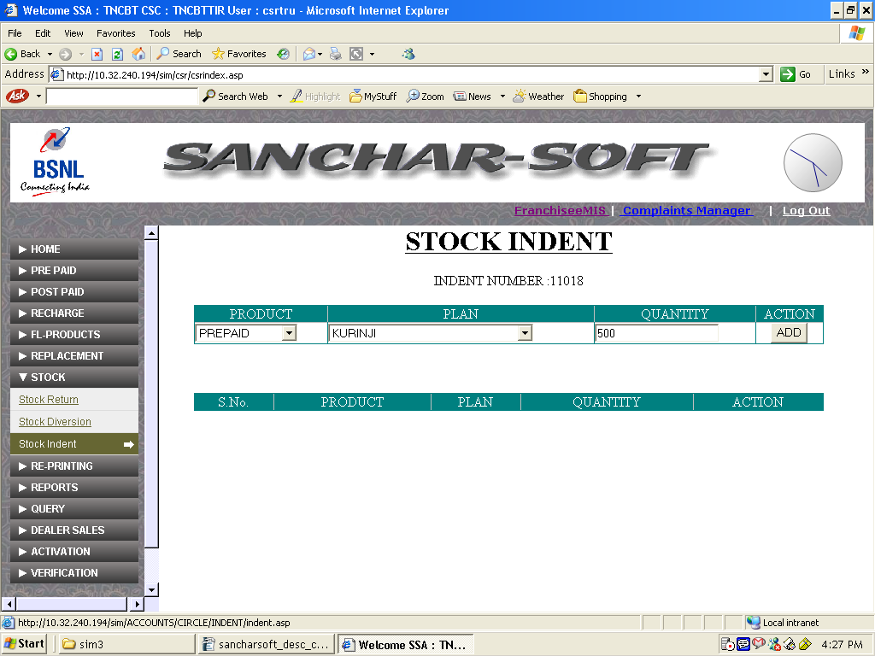

6) RE-PRINTING:

This menu facilitates re-printing the invoices of Prepaid, Replacement, additional deposit, CTOP UP recharge, PCO/DSA invoice and stock return. For certain reprinting an option to search for invoices originally printed between two dates is also available. The sub menus available are:
a) Prepaid
b) Replacement
c) CTOPUP recharge
d) PCO/DSA invoice
e) stock return

6.a) Reprinting – Prepaid
Through this menu reprinting of receipts related to prepaid could be obtained after entering the GSM number.

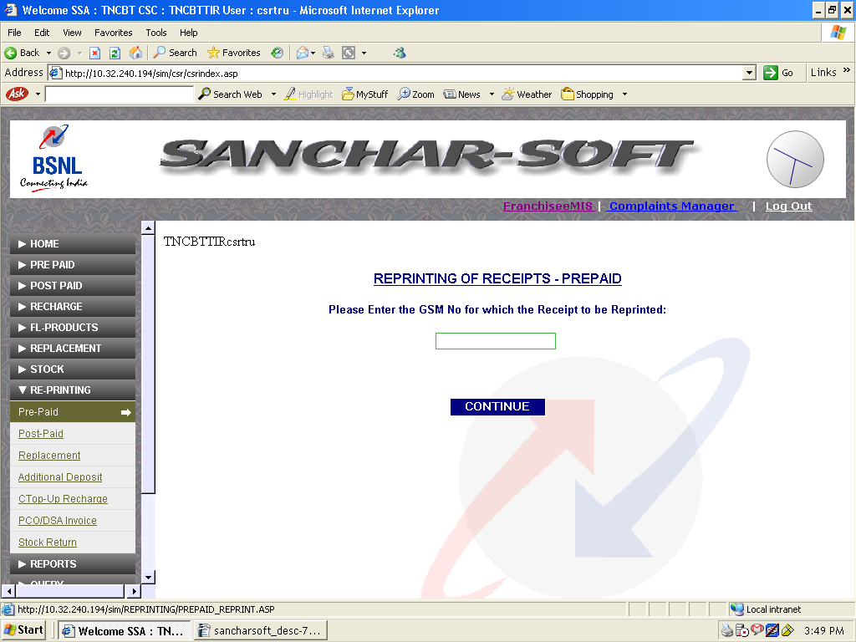

6.b) Reprinting – Replacement

Replacement reprinting sub menu facilitates for reprinting the invoices with an option to search for invoices originally printed between two given dates.

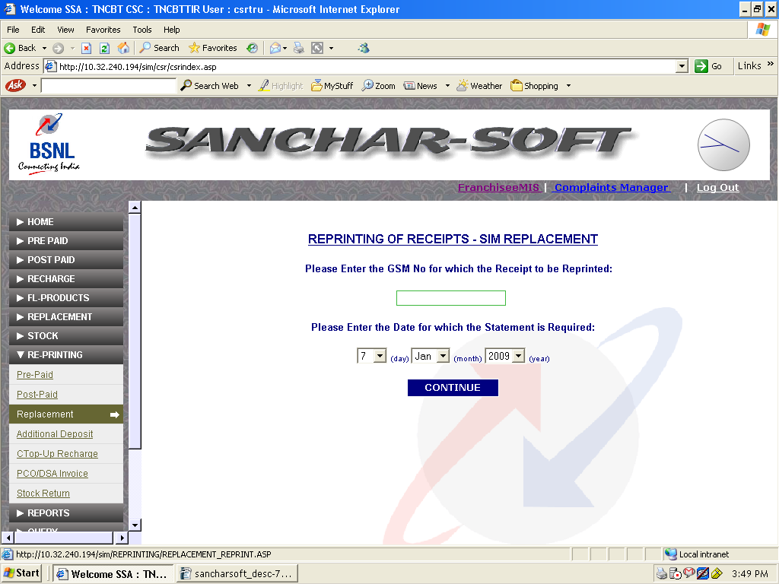

  - Reprinting – PCO/DSA invoice:
This menu of reprinting PCO/DSA invoice will reprint the selected invoice after entering the dates within which it should display the invoices.

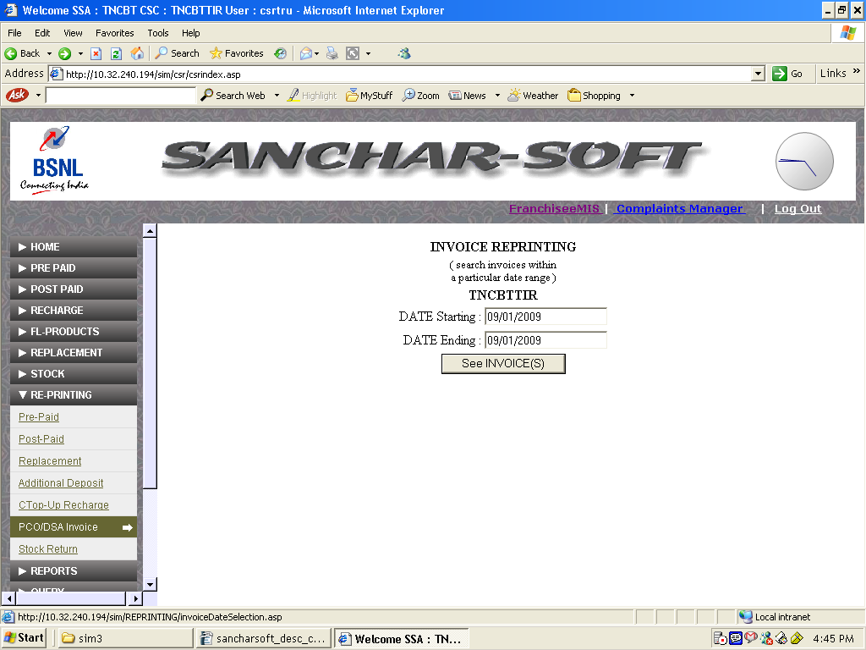

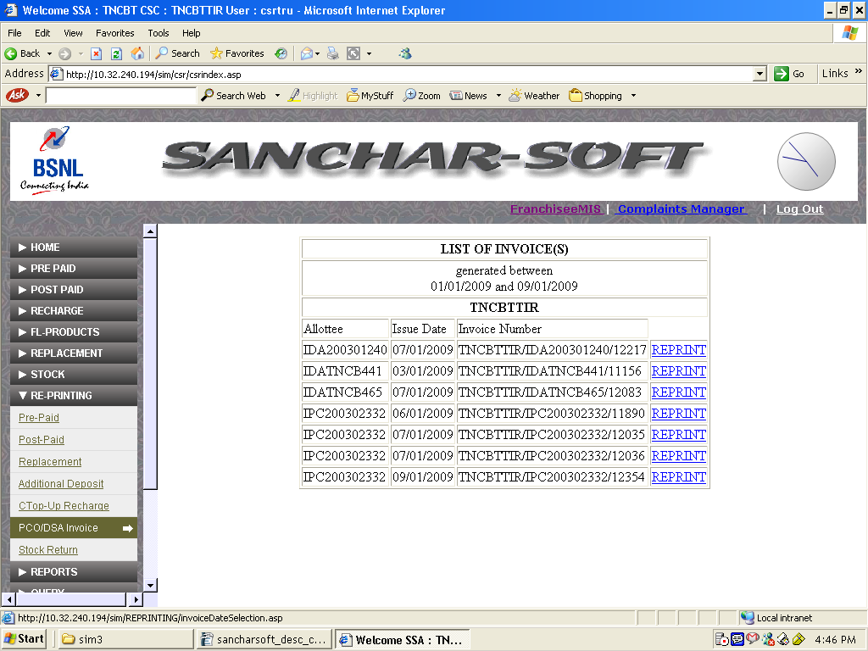

6.d) Reprinting – Stock Return

This sub menu is used to re print the stock return invoices by giving an option to select from the list displayed in between two given dates.

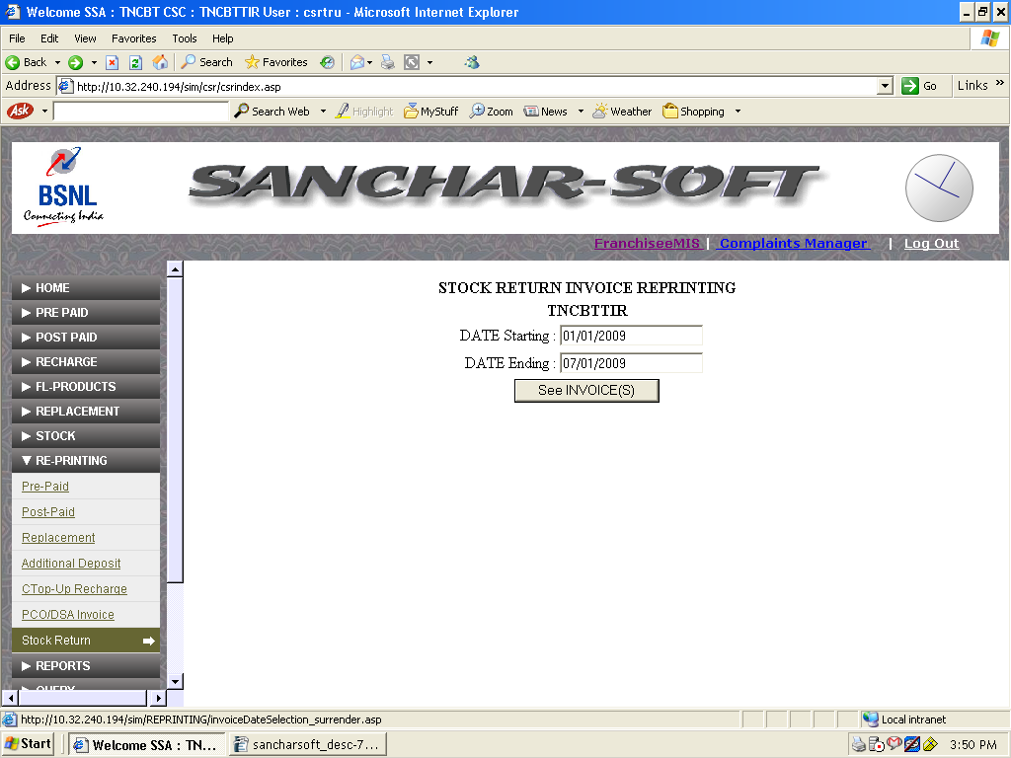

7) REPORTS:
This menu provides various reports for the transactions happened, in three fashions.
a) Daily statement
b) Consolidated sales
c) Stock

Daily statement provides us the daily sales summary report for the logged in CSR or the daily sales summary report for the CSR, user wise - if more than one user is available in CSR.
The consolidated sales report provides the category wise reports such as prepaid sales list, Recharge sales list etc between two given dates.
The stock option provides the report for the stock received in between two dates, the currently available stock of the logged in CSR, the stock details of the DSA/STD PCO connected to the logged in CSR.

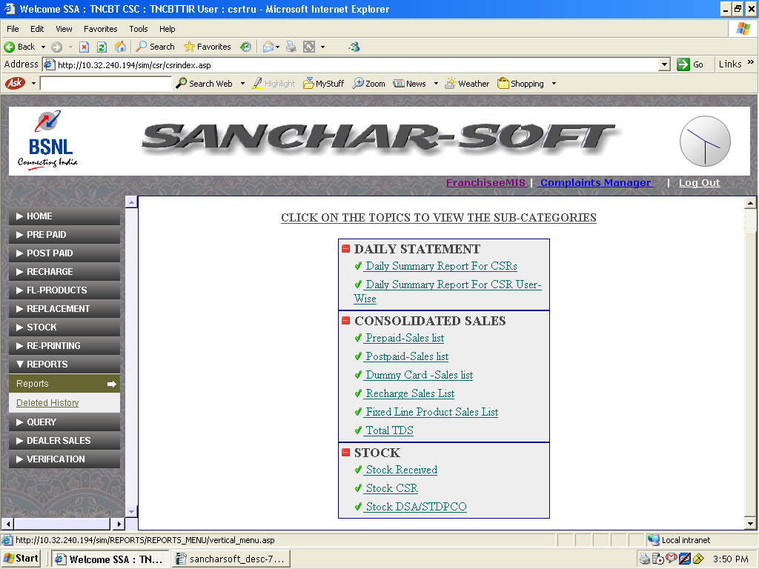

7.a.i) Daily statement – Daily summary report for CSR

This sub menu displays the report of the sales of cards under various categories for a given day in CSR.

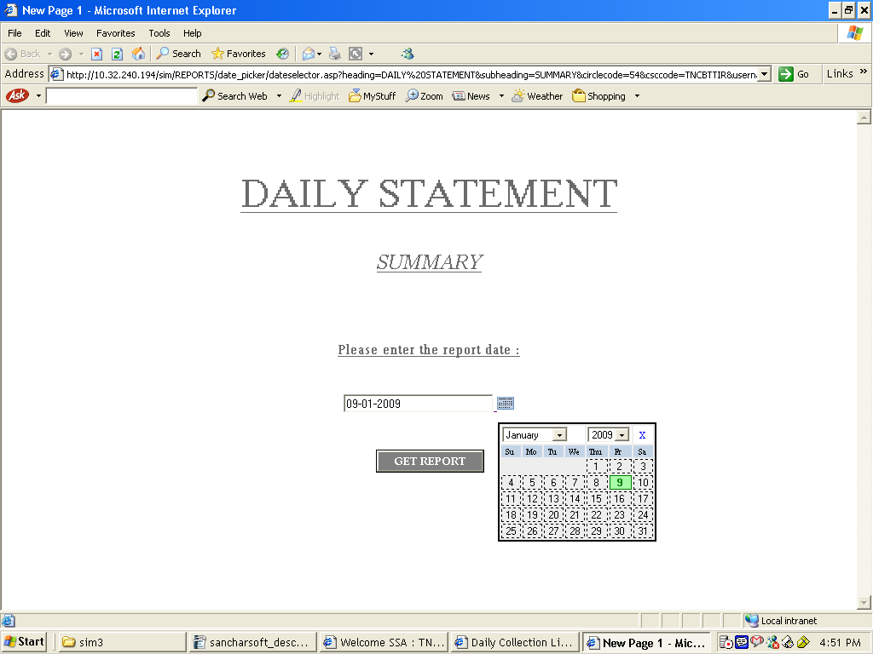

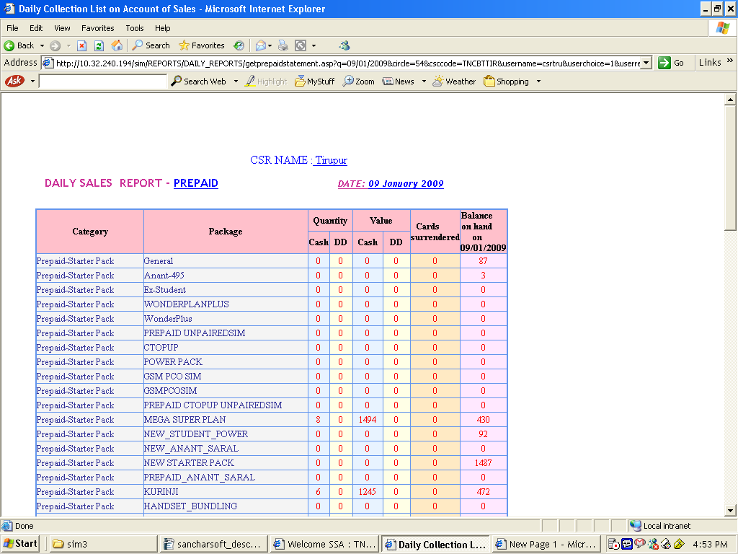
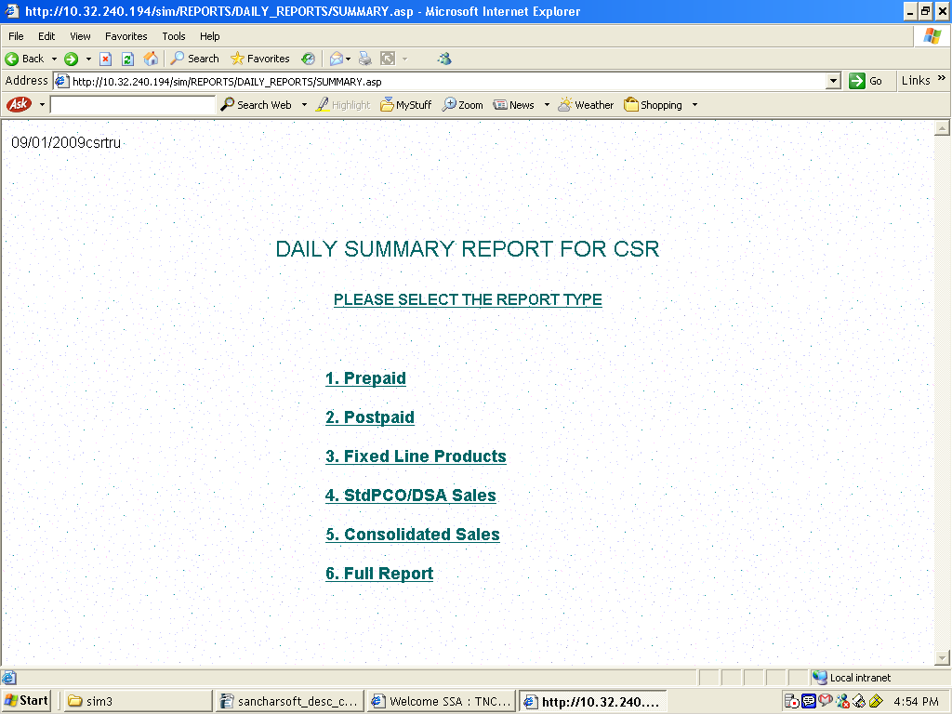

7.a.ii) Daily statement – Daily summary report for CSR – userwise

Summary report for one particular user in a CSR could be got from this sub menu by selecting the particular username in the drop down menu.

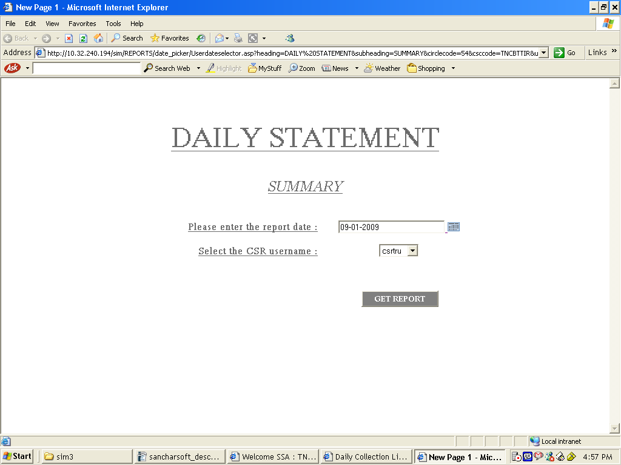

7.b) consolidated sales :
Cosolidated sales report provides the sale details happened between two given dates with more customer specific details.

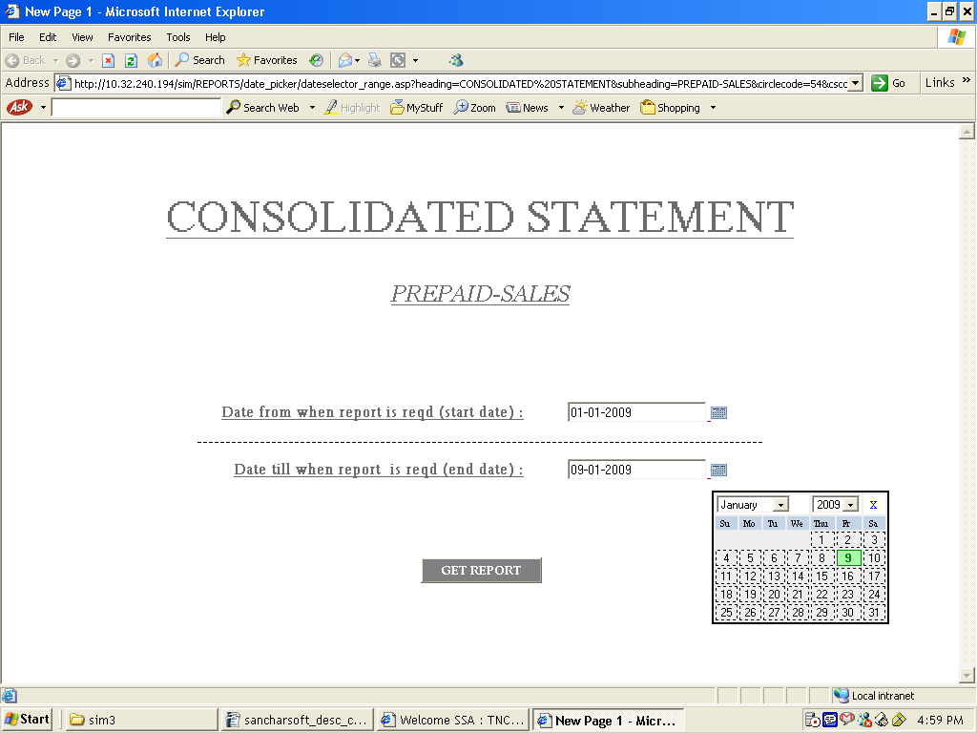

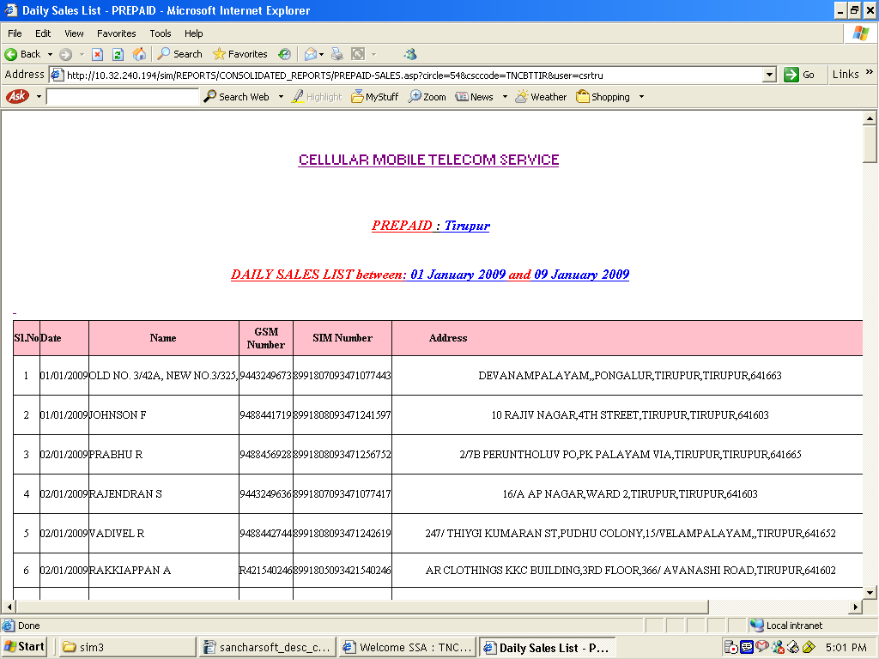

    - Stock Received:
Stock received report sub menu provides the report of the total stock received from SSA A.O or other unit between to given dates product / category wise.

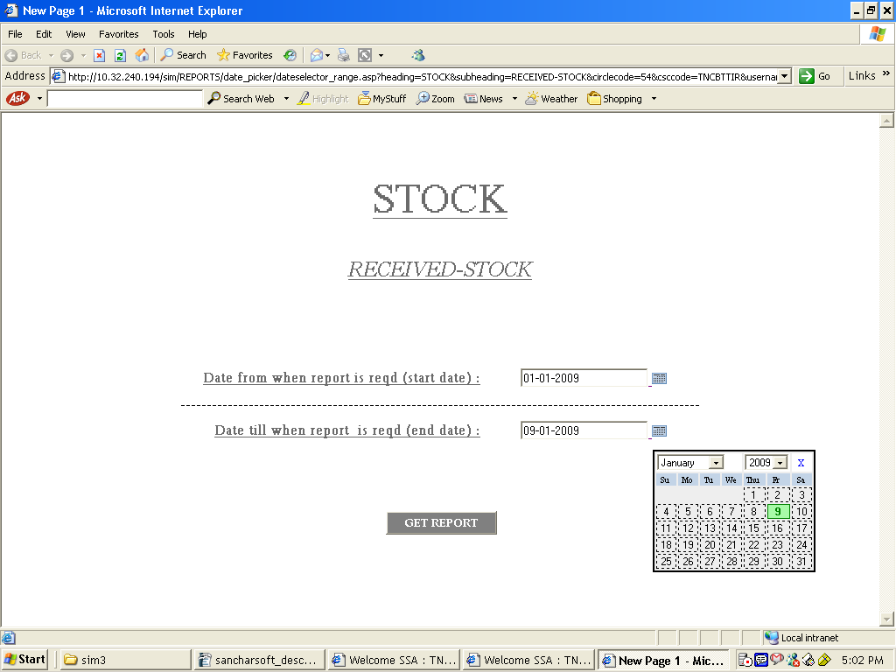

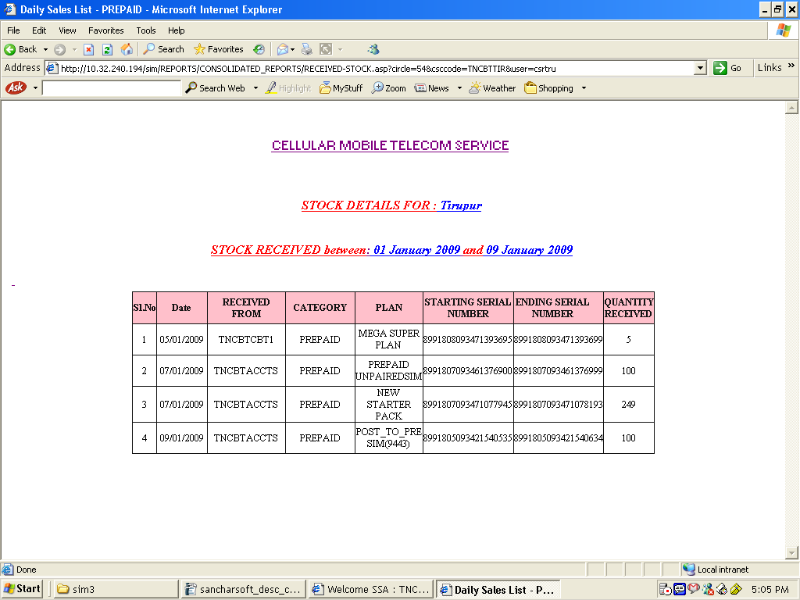

    - Stock CSR:
This report provides the totak available stock in the CSR as on date productwise and planwise.

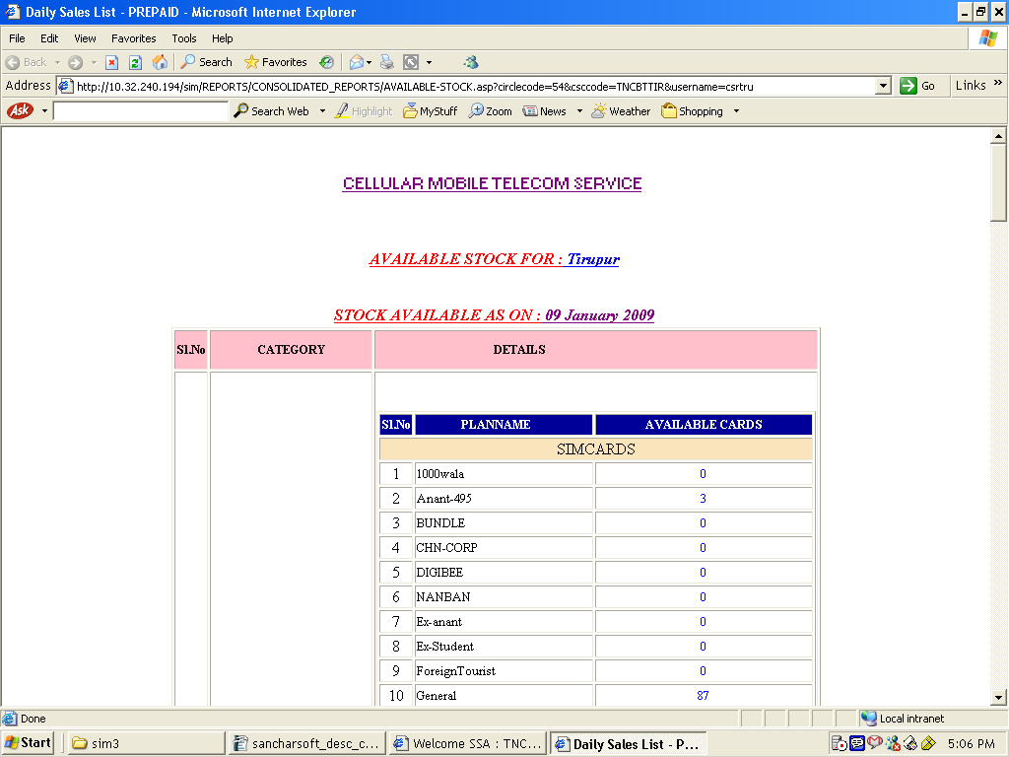

    - Stock DSA/ STDPCO
This report provides the stock available in the hands of the DSA / STDPCO as on date.

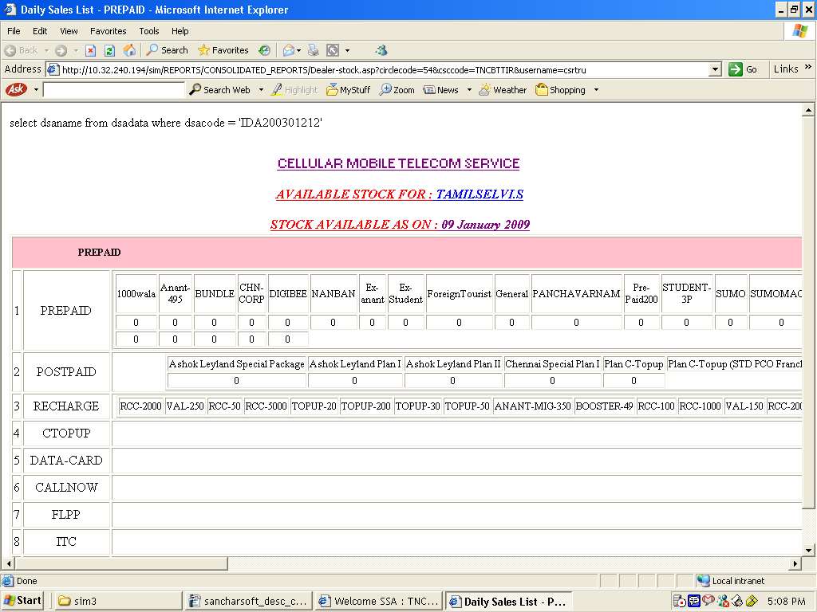

T

8) QUERY:

Through the query menu the SIM, Recharge / TOP-UP history, movement and location could be traced.
In the sub menu SIM history the SIM Training could be done either through SIM Number or Mobile Number. The Recharge / TOP-UP coupons could be traced through the coupon number.

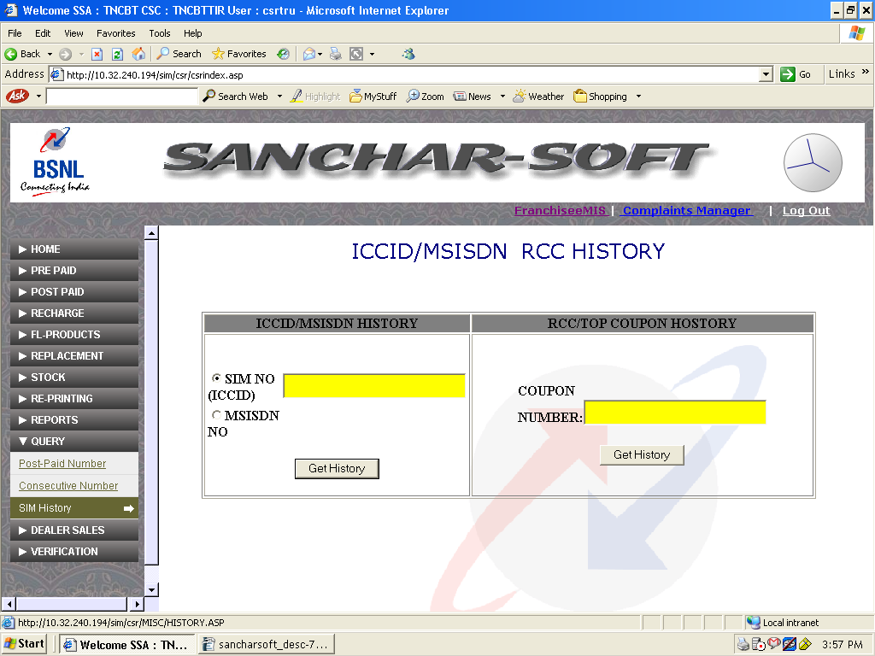

9) DEALER SALES:
Dealer sales menu facilitates the sales of SIM Cards, Recharge / TOP-UP cards to franchisee / STD PCO / DSA as well as provision for entering the details of CAF received from DSA / STD PCO and also provision to cancel the invoice created if to be done.The sub menus are:
a) invoice cancel
b) Franchisee
c) STDPCO
d) DSA
e) EPIN
f) CTOPUP
g) CAF Dataentry
h) Prepaid name transfer
9.a) invoice cancel:
TO cancel any invoice prepared erroneously this sub menu could be used. But caution to exercised while preparing invoice so that this usage is avoided. By entering two dates within which invoices are to be cancelled, the report will display all the invoices prepared during that period. Then the erroneous invoice may be cancelled by clicking CANCEL INVOICE.
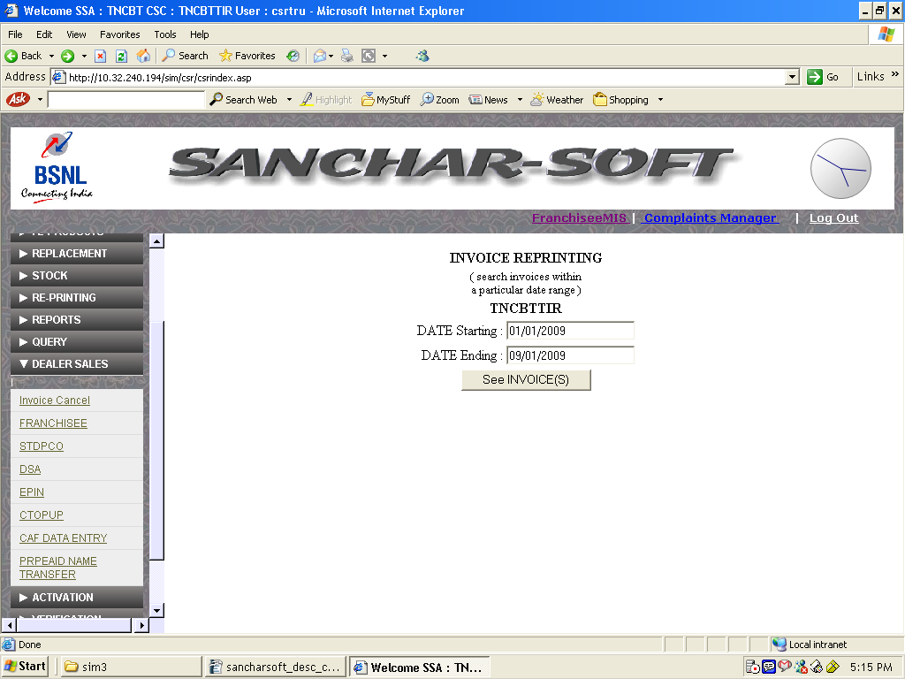

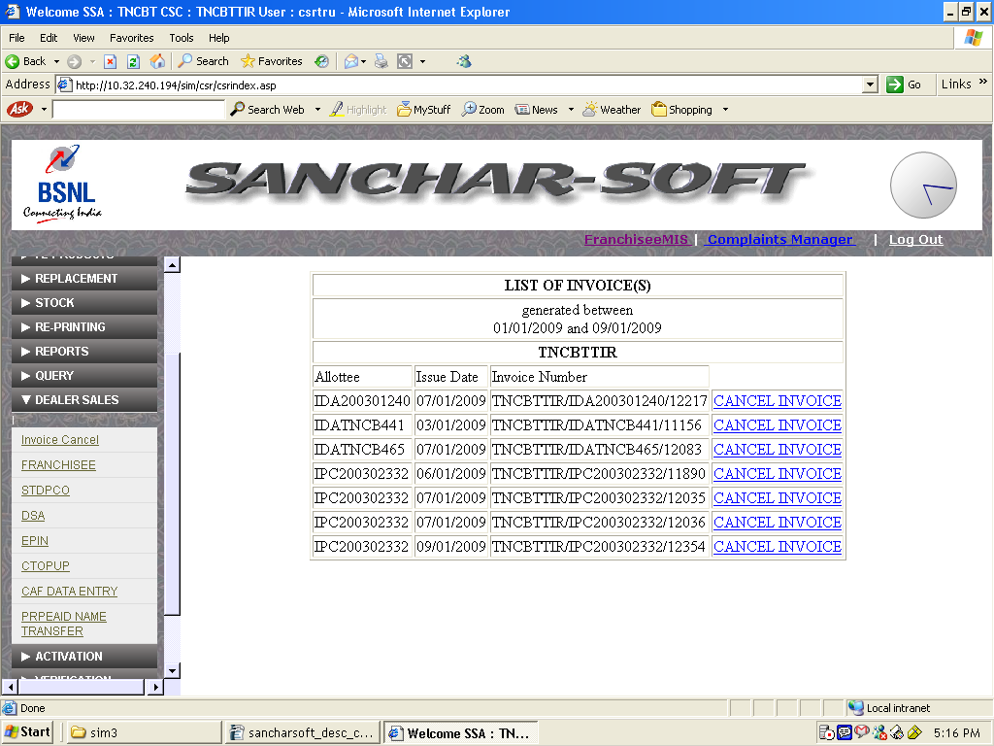

9.b) Franchisee / STDPCO / DSA / EPIN / CTOPUP
Sales to dealers such as Franchisee, STDPCO, DSA, EPIN, CTOPUP could be done thro the sub menus given. In this the Franchisee, STDPCO, DSA, EPIN, CTOPUP, Product, Plan, starting number and quantity are to be selected. Then by clickin the relevant link for confirmation the sale could be effected.

Franchisee sales:

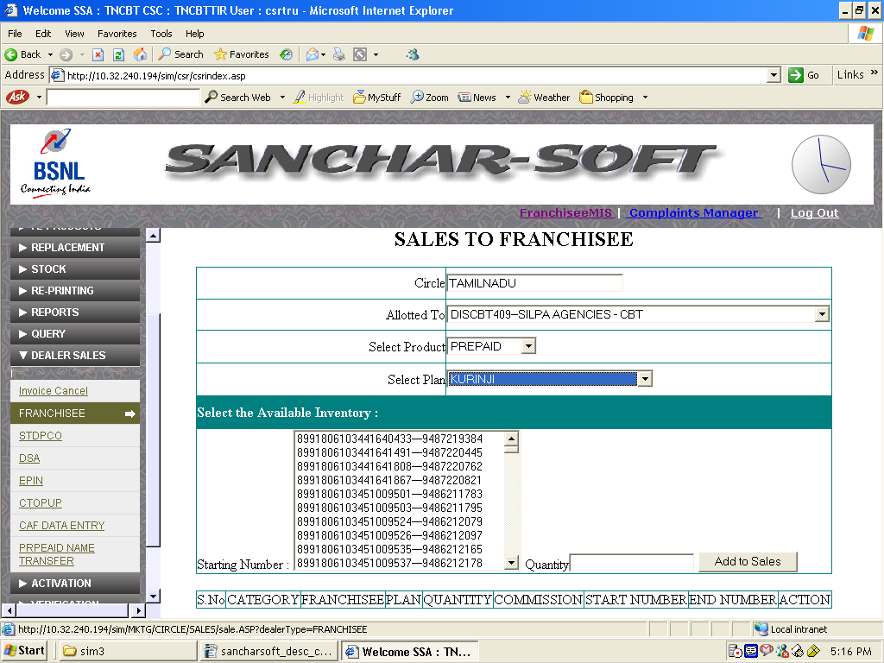

STDPCO sales:
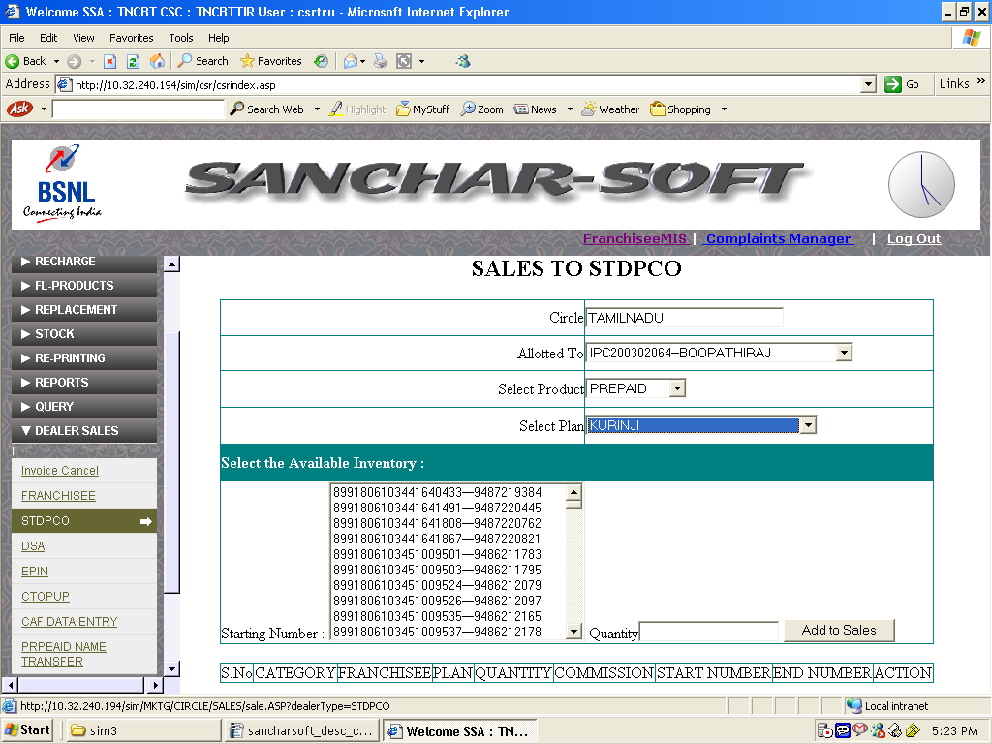
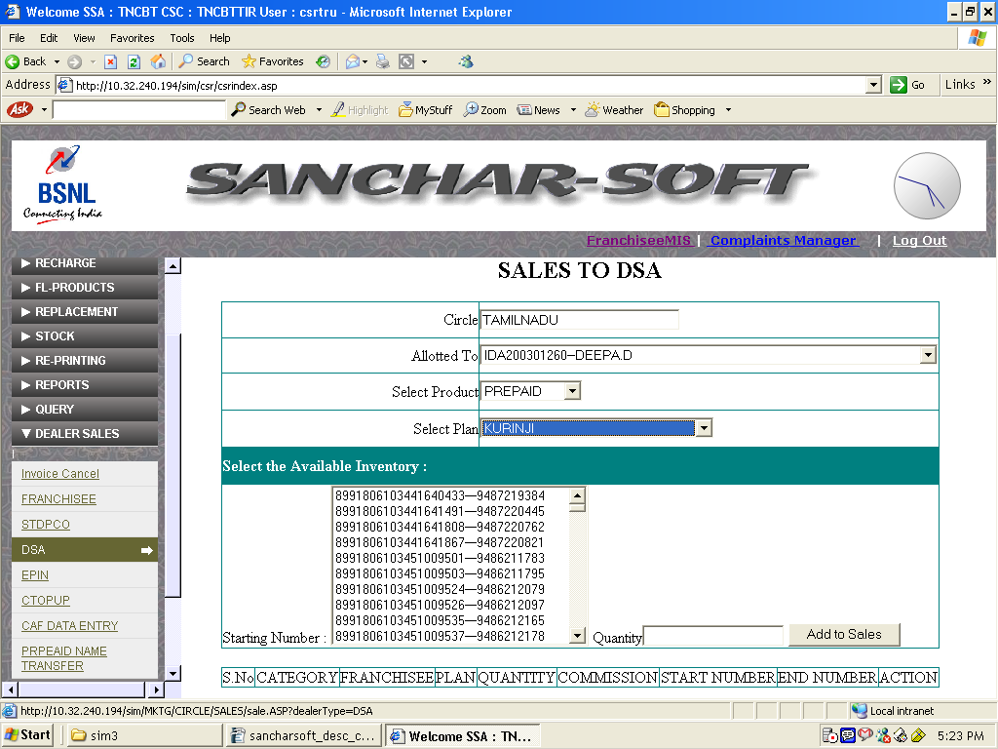
DSA:

CTOPUP:
This facility is to generate invoice and collect cash, at CSRs . This receipt / report is available to A.O of SSA. A.O of SSA based on this report can order PYRO , thro his login to recharge the amount specified here to the franchisee /DSA /PCO. Then AO will update web page with Pyro Reciept number same can be seen by CSR.
(This is for accounting revenue from CTOP UP, does not recharge directly to Pyro / Estel system.)

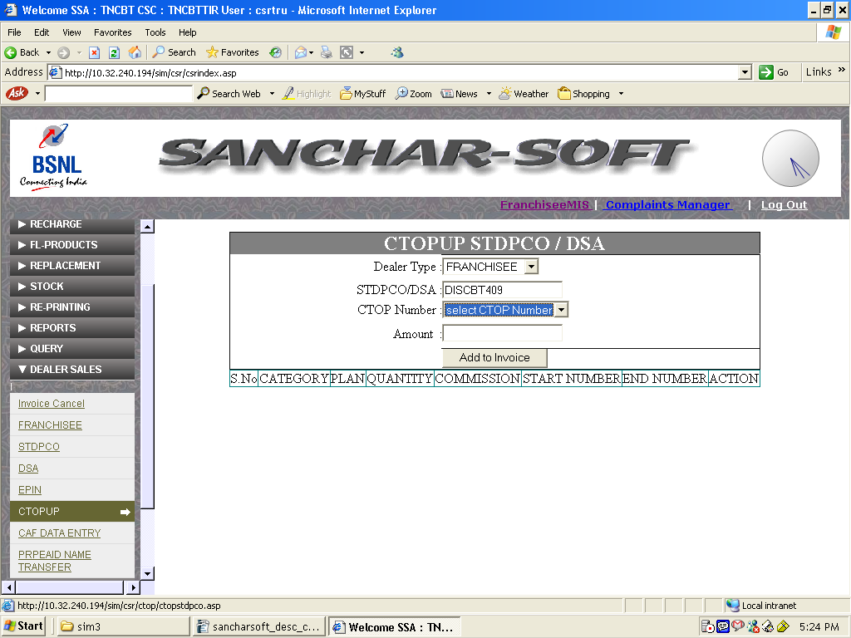

9.g) CAF DATA Entry:
This menu facilitates for entering the CAF details of the SIM cards for Franchisee, STDPCO, DSA etc..

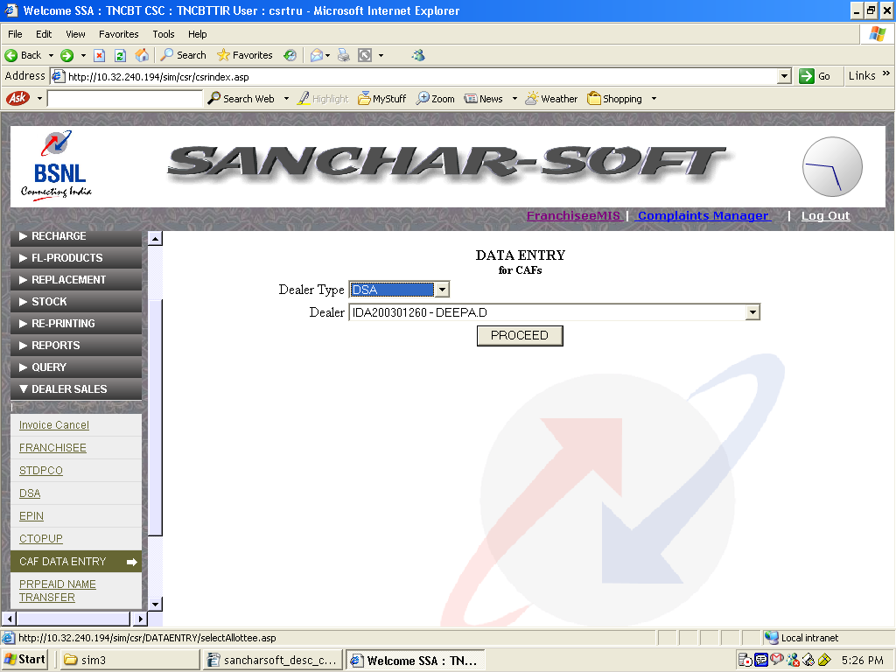
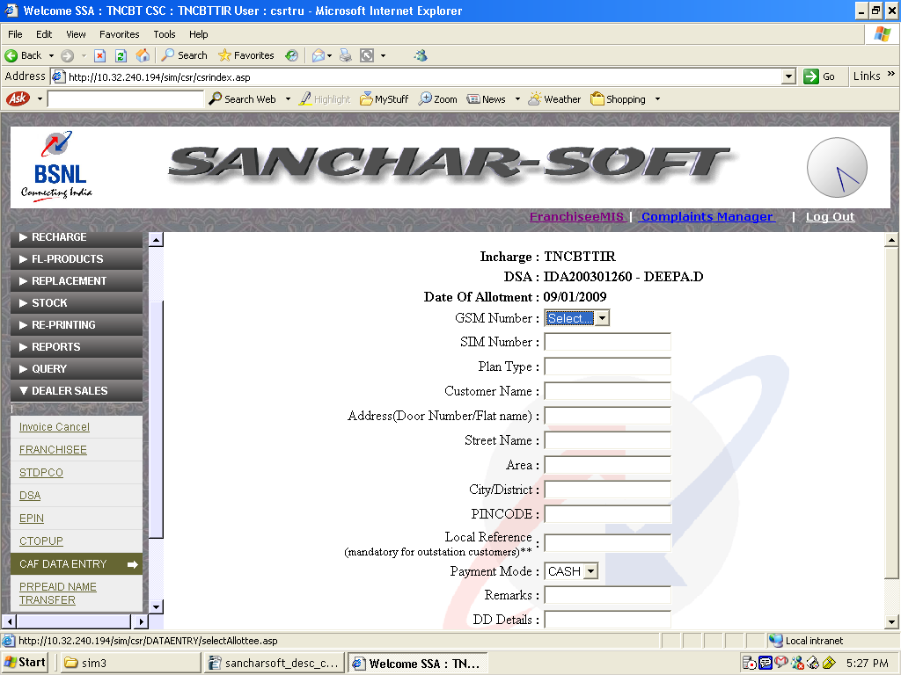
9.h) Prepaid Name Transfer:
This menu is used for entering the name transfer / regularisation and relted activities.
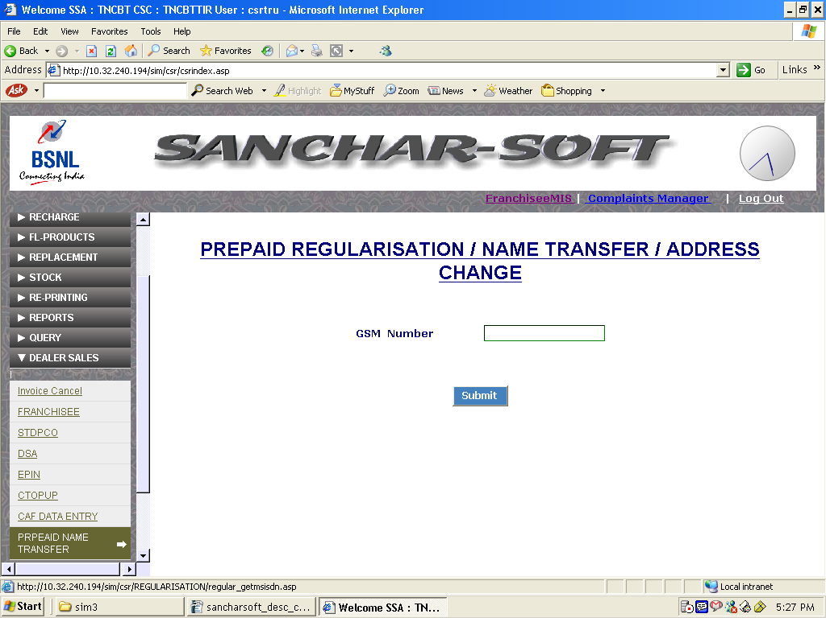

10 Activation:
Activation menu helps in getting the activation status of a SIM sold and sent for activation. For this the SIM /MSISDN number has to be entered and by clicking the get activation status it could be seen.



